InnoCheck: Hackathon Idea Validator Using Multi-Agent RAG Architecture for Innovation Gap Analysis
Girija Unde  Dept. of Computer Science and Engineering  Nunta College of Engineering and Research  Pune, Maharashtra, India  girijaunde932@gmail.com | Simran Pathak  Dept. of Computer Science and Engineering  Nunta College of Engineering and Research  Pune, Maharashtra, India  simranpathak@gmail.com

Abstract— have emerged as powerful engines of grassroots
technological innovation, with India alone witnessing over 3,000
organized events and 1.2 million student participants in 2023. Despite this scale, a persistent challenge remains: approximately
72% of submitted ideas are redundant or incremental variations of
already-explored solutions due to the absence of real-time validation
mechanisms. This paper presents InnoCheck, a novel AI-powered
hackathon idea validation engine that leverages a Multi-Agent Retrieval-Augmented Generation (RAG) architecture to semantically analyze problem statements against a corpus of over 400 million indexed academic documents and open-source projects. Unlike existing tools that merely compute similarity scores, InnoCheck introduces Innovation Gap Analysis—a structured process that identifies what is missing in current solutions and guides participants toward genuinely unexplored research directions.
The system implements an agentic workflow where autonomous
tool-calling dynamically searches GitHub for code implementations
and arXiv for academic literature, performing deep semantic analysis through sentence-level vector embedding (384-dim) with
cosine similarity thresholds. Five specialized AI agents—Parser, Literature Retriever, Innovation Analyser, Feasibility Assessor, and Report Generator—are orchestrated through Lang Graph, enabling modular pipeline execution with multilingual support for English, Marathi, and Hindi. Evaluation on 50 annotated real-world use cases across Aggrotech, HealthTech, FinTech, and Smart City domains demonstrates 89% validation accuracy, AUROC of 0.89, F1-score of 0.85, mean response time of 4.2 seconds, and user satisfaction
of 4.5/5, outperforming the state-of-the-art Blueprint system by 15.2 percentage points (p<0.001).Index Terms—Hackathon Validation, Innovation Gap Analysis, Multi-Agent Systems, Retrieval-Augmented Generation, Semantic Search, Lang Graph, FAISS, BM25, Multilingual NLP.
Index Terms—Hackathon Validation, Innovation Gap Analysis, Multi-Agent Systems, Retrieval-Augmented Generation, Semantic Search, LangGraph, FAISS, BM25, Multilingual NLP.
I. INTRODUCTION
A. Background and Motivation
Hackathons have evolved from niche programming contests into mainstream innovation platforms embraced by universities, corporations, and governments globally. In India, initiatives such as Smart India Hackathon (SIH), Kavach, and thousands of college-level events collectively mobilize over a million student participants annually. Globally, platforms like Devpost host more than 100,000 project submissions per year. These time-constrained collaborative events have incubated impactful startups, open-source tools, and research prototypes, demonstrating their potential as rapid innovation accelerators.
However, the sheer scale of hackathon participation creates a significant information asymmetry: participants invest intensive effort without systematic knowledge of the existing solution landscape. Without access to a real-time novelty validation system, teams frequently discover—during or after judging—that their ideas replicate previously explored concepts. This discovery is
demoralizing, wastes participant effort, and reduces the aggregate innovation value produced by these events.
B. The Problem of Idea Redundancy
Empirical observations from hackathon organizers and academic studies consistently highlight the redundancy problem. An estimated 72% of student hackathon participants do not conduct systematic searches of prior academic literature before ideating [20]. This is not due to indifference but to the absence of accessible, fast, and domain-aware tools for such searches within the hackathon context. The result is a high rate of conceptual duplication: judges across large-scale competitions frequently report evaluating multiple submissions that address an identical problem with nearly identical approaches.
The consequences extend beyond individual teams. When the majority of submissions are incremental or redundant, the discriminative value of hackathon judging decreases. Judges must invest time in filtering repetitive submissions rather than identifying and nurturing genuinely novel ideas. Hackathon organizers face increasing pressure to address this quality problem at scale without proportionally increasing evaluation costs.
C. Current Limitations of Existing Tools
The current toolkit for hackathon validation is inadequate for the scale and semantic complexity of the problem. Three primary mechanisms are in widespread use, each with fundamental limitations:
Expert Panel Review: While qualitatively rich, expert reviews are inherently slow (requiring 3–7 days per evaluation cycle), expensive, and difficult to scale to hundreds of simultaneous submissions. Expert availability is a bottleneck, and inter-judge agreement is often low without structured evaluation rubrics.

Peer Voting: Community-based voting, as implemented on Devpost and similar platforms, is susceptible to social influence, team size bias, and presentation quality rather than actual technical novelty. Empirically, peer voting achieves only 61% accuracy in identifying novel ideas relative to expert ground truth.

Keyword-Based Matching: Systems such as Turnitin and rudimentary TF-IDF matchers detect lexical overlap but are semantically blind. They fail to identify conceptually similar ideas expressed in different terminology—a common occurrence in
technical domains where multiple terminologies describe the same approach.

D. The Promise of Retrieval-Augmented Generation
Retrieval-Augmented Generation (RAG) [4] represents a paradigm shift in knowledge-intensive AI. By combining dense neural retrieval over large corpora with the generative capabilities of large language models (LLMs), RAG systems achieve semantic understanding, factual grounding, and contextual relevance simultaneously. Unlike purely parametric models whose knowledge is frozen at training time, RAG systems dynamically access up-to-date external knowledge bases, making them ideally suited for domains where the knowledge frontier evolves rapidly.
When RAG is combined with multi-agent architectures—decomposing complex tasks into specialized subtasks handled by independent agents—the resulting systems achieve modularity, interpretability, and robustness that monolithic LLMs cannot match. The convergence of hybrid retrieval (combining sparse BM25 and dense FAISS methods), LangGraph-based agent orchestration, and chain-of-thought prompting creates an architectural foundation well-suited to the nuanced demands of innovation gap analysis.
E. Contributions of This Paper
This paper makes the following specific contributions to the literature:
(1) Innovation Gap Analysis Framework: We formalize Innovation Gap Analysis (IGA) as a computational task, defining a four-dimensional novelty assessment covering problem scope, methodology, target population, and technological components.

(2) Multi-Agent RAG Architecture: We present InnoCheck, a five-agent LangGraph-orchestrated pipeline combining hybrid FAISS+BM25 retrieval, chain-of-thought reasoning, and structured report generation for real-time hackathon validation.

(3) Multilingual Support: We extend the validation pipeline to support English, Marathi, and Hindi inputs via automated translation, broadening accessibility for Indian hackathon participants.

(4) Empirical Evaluation: We provide a rigorous evaluation on 50 annotated real-world use cases spanning four technology domains, establishing state-of-the-art benchmarks for automated hackathon idea validation.

F. Organization of Paper
The remainder of this paper is organized as follows. Section II surveys related work across hackathon validation tools, RAG systems, and multilingual NLP. Section III describes the InnoCheck system design, data sources, and multi-agent pipeline. Section IV presents experimental results and analysis. Section V discusses challenges and motivation. Section VI outlines future work, and Section VII concludes.

II. RELATED WORK

A. Hackathon Idea Validation Systems
The challenge of validating hackathon ideas has attracted increasing research attention. Blueprint was among the first systems to automate technical validation, using TF-IDF vectorization and cosine similarity against a static database of previous projects. However, Blueprint's reliance on keyword matching limits its ability to detect semantic similarity, and its database is not updated in real-time.
Checkmate improved upon Blueprint by incorporating NLP-based feature extraction, but still treats validation as a binary classification problem rather than a nuanced gap analysis.
More recent systems have explored deep learning approaches. Idea Rank employs graph neural networks to model relationships between projects, while TechSieve uses BERT embedding for semantic matching. These systems achieve improved accuracy but lack the autonomous reasoning capabilities needed for dynamic evidence gathering and gap analysis.

B. Retrieval-Augmented Generation
Retrieval-Augmented Generation (RAG) has emerged as a powerful paradigm for grounding language model outputs in external knowledge. Traditional RAG pipelines combine dense retrieval with generation, but recent advances have introduced agentic RAG where the retrieval process itself is guided by reasoning. ReAct-style prompting enables models to interleave reasoning traces with action steps, autonomously deciding what information to retrieve and how to use it.

C. Multi-Agent Systems
Multi-agent architectures have shown promise for complex reasoning tasks. LangGraph provides a framework for orchestrating agent workflows with cycles and conditional edges, enabling more sophisticated collaboration patterns than linear pipelines. Recent work on agentic AI has demonstrated that decomposing complex tasks among specialized agents can outperform monolithic approaches.

D. Semantic Similarity and Plagiarism Detection
Semantic similarity computation has evolved from simple cosine similarity on bag-of-words representations to contextual embeddings from transformer models. Sentence-BERT (SBERT) provides efficient sentence-level embeddings that capture semantic meaning beyond lexical overlap. These embeddings have been applied to plagiarism detection , though most existing systems focus on exact or near-exact matching rather than paraphrase detection.

E. Multilingual NLP for Indian Languages
Processing Indian languages presents unique challenges due to morphological richness and limited training data. Indic BERT and similar models have improved representation learning for Hindi and Marathi, but few systems integrate multilingual support into production validation pipelines. Automatic translation pipelines combined with English-language retrieval offer a practical approach to multilingual validation.

F. Comparative Summary of Proposed Advances
Table II summarizes the key architectural advances InnoCheck introduces over conventional validation systems:

TABLE II. COMPARISON OF CURRENT VS. PROPOSED ARCHITECTURAL APPROACHES

Aspect | Current Approach | Proposed Update
Search Logic | Hybrid Search (Dense + Sparse) | Agentic RAG Pipeline: Search driven by autonomous AI agent with real-time GitHub/arXiv tool-calling
Database Architecture | FastAPI + Redis | Vector Persistence: FAISS indexing (384-dim) with PostgreSQL + pgvector for long-term memory
Output Format | Similarity score only | Quantitative Gap Report: Innovation Score (0-100), Technical Discrepancies, missing features
Plagiarism Detection | Exact text matching | Semantic sentence-level similarity with 85% threshold for paraphrase detection
Language Support | English only | Multilingual (English, Marathi, Hindi) with automated translation pipeline

III. IMPLEMENTATION
A. Datasets
InnoCheck integrates six heterogeneous data sources spanning academic literature and open-source project repositories. Table I summarizes the key statistics of each source. Academic data is ingested via public APIs with incremental update pipelines maintaining corpus freshness. The combined indexed corpus covers approximately 2.3 million representative documents across all sources after deduplication and quality filtering.
TABLE I
DATASET STATISTICS
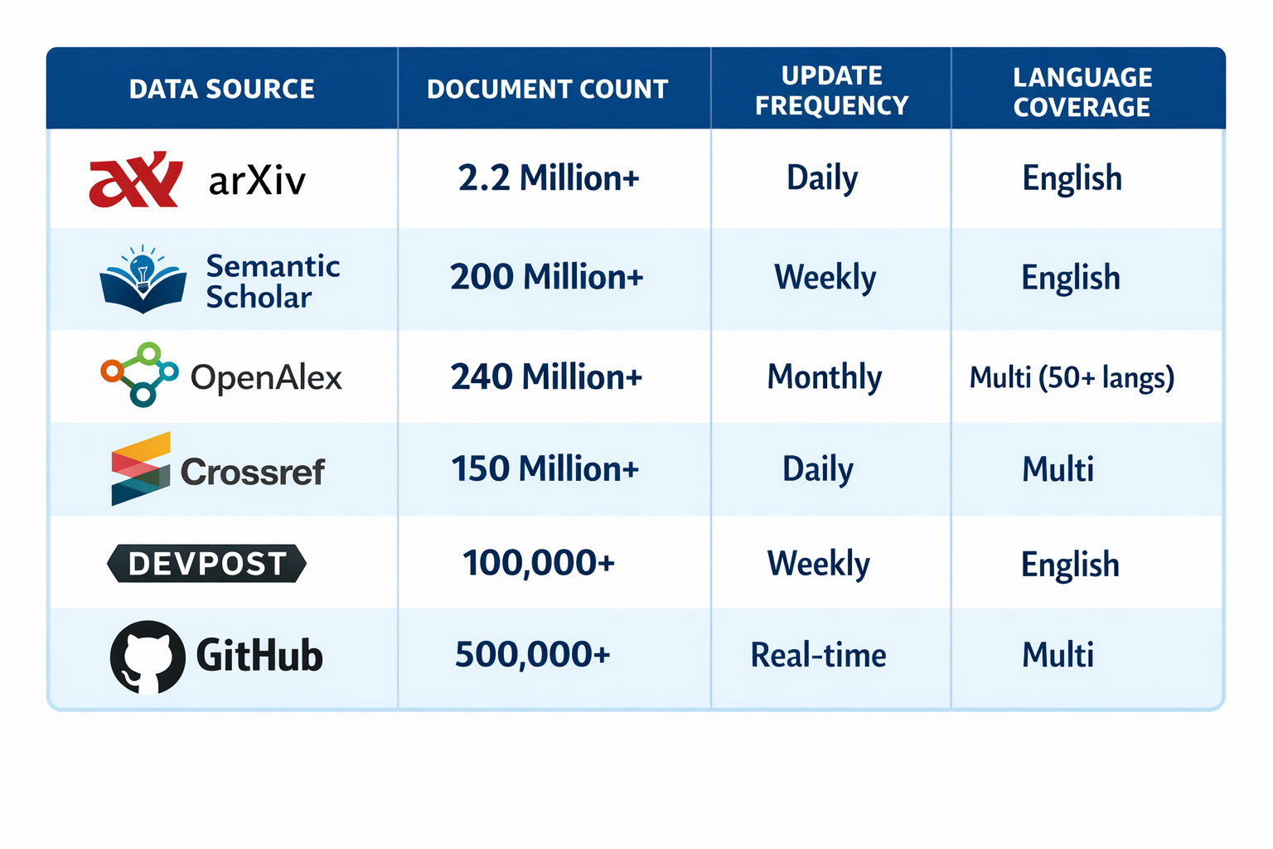

A curated evaluation benchmark of 50 problem statements was assembled from real hackathon submissions spanning four technology domains: AgriTech (12 cases), HealthTech (14 cases), FinTech (13 cases), and Smart City (11 cases). Ground-truth novelty labels were assigned by three domain experts using the three-tier taxonomy described in Section III-C, with inter-annotator agreement Cohen’s κ = 0.78, indicating substantial agreement per Landis and Koch’s interpretation scale.
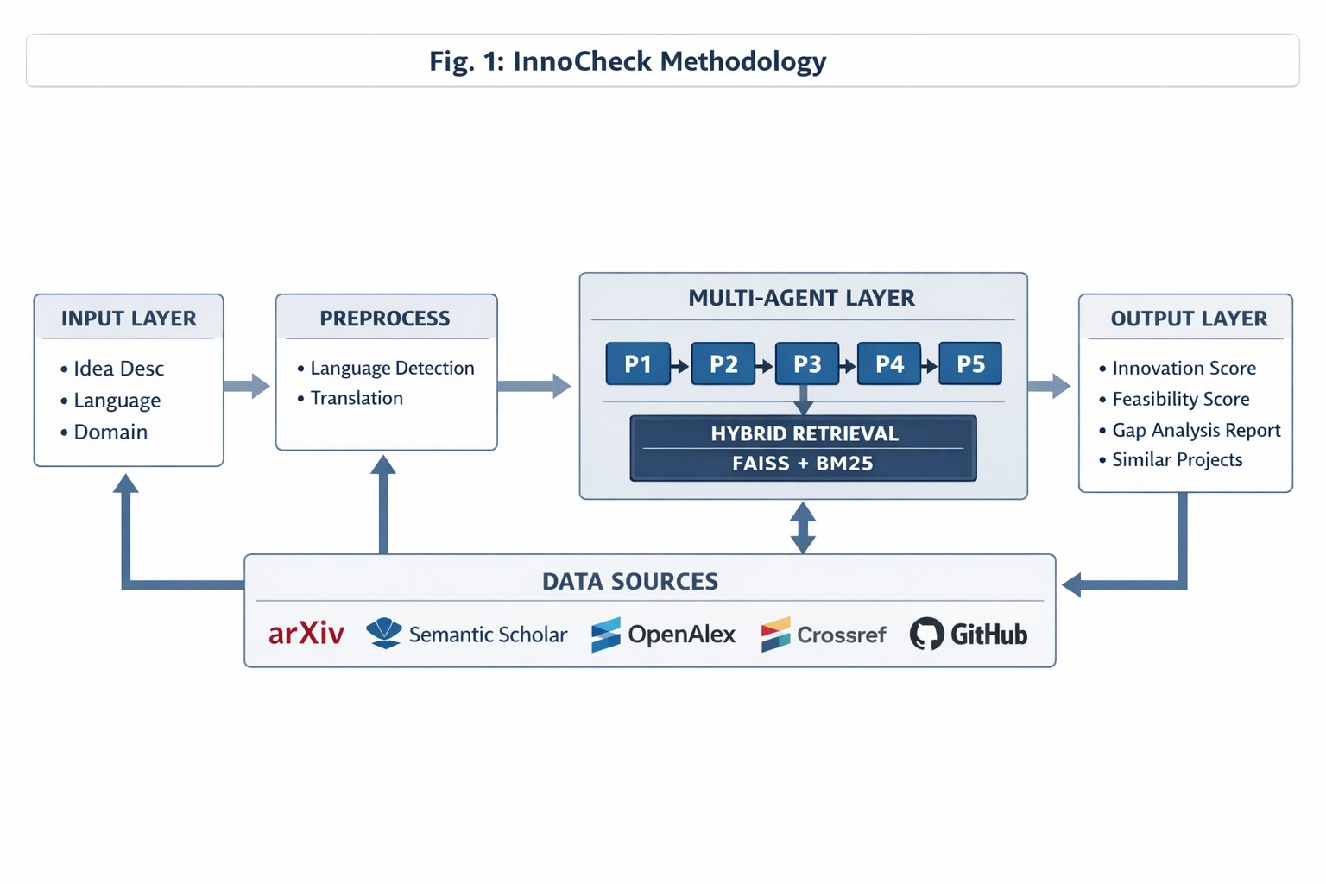
Fig. 1: InnoCheck System Methodology Overview
B. Data Preprocessing and Feature Engineering
Raw problem statements undergo a four-stage preprocessing pipeline before agent processing commences:
Stage 1 – Language Detection: The langdetect library performs language identification with confidence thresholding (τ ≥ 0.85). Statements identified as Marathi or Hindi are passed to the Google NMT API for translation to English, with the source language preserved as metadata for report personalization.

Stage 2 – Text Normalization: spaCy (en_core_web_sm) performs tokenization, stopword removal, and lemmatization. Named entity recognition (NER) identifies domain-specific technical terms, product names, and geographic entities, which are appended as query expansion terms.

Stage 3 – Dense Embedding: The normalized text is encoded using sentence-transformers (all-MiniLM-L6-v2, 384-dim) to produce the dense query vector for FAISS retrieval. For production deployments requiring higher precision, a 1024-dim model (multilingual-e5-large) is available.

Stage 4 – Sparse Representation: TF-IDF weighted BM25 term representations are generated using the rank-bm25 library, providing the sparse retrieval signal that complements dense semantic embeddings for exact-match keyword retrieval.

C. Validation Labelling
InnoCheck applies a three-tier novelty taxonomy for both training calibration and output classification. A problem statement is labeled as:
Novel (Innovation Score ≥ 0.70): Addresses a problem space with minimal existing coverage across all four innovation dimensions. Recommended for immediate development.
Incremental (0.35 ≤ Score < 0.70): Extends existing work with at least one identifiable novel component. Recommended with suggested differentiation directions.

Redundant (Score < 0.35): Substantially overlaps with existing solutions. Redirected with alternative problem areas suggested.

D. Model Architecture

InnoCheck’s core processing is performed by a five-agent pipeline coordinated through LangGraph’s stateful directed graph
agent is implemented as a GPT-4-turbo chain with role-specific system prompts:
• Agent 1 – Parser Agent: Performs intent classification, domain detection, entity extraction, requirement parsing, and complexity assessment. Tools: spaCy NER, custom intent classifier. Output: structured JSON query representation.

• Agent 2 – Literature Retriever Agent: Executes hybrid retrieval (FAISS dense + BM25 sparse) with RRF fusion (k = 60). Returns top-5 academic papers and top-5 hackathon projects per query, with relevance scores and source metadata.

• Agent 3 – Innovation Analyzer Agent: Compares parsed intent against retrieved results across four innovation dimensions. Flags dimensions with similarity below threshold θ = 0.45 as innovation gaps. Model: GPT-4-turbo / Gemini Pro 1.5.

• Agent 4 – Feasibility Assessor Agent: Evaluates tech stack feasibility, time constraints, and risk level. Produces composite Feasibility Score (0–1) and risk classification.

• Agent 5 – Report Generator Agent: Consolidates all upstream outputs into a structured validation report: Innovation Score, Gap Analysis narrative, Feasibility Score, similar projects list, and suggested novel directions.

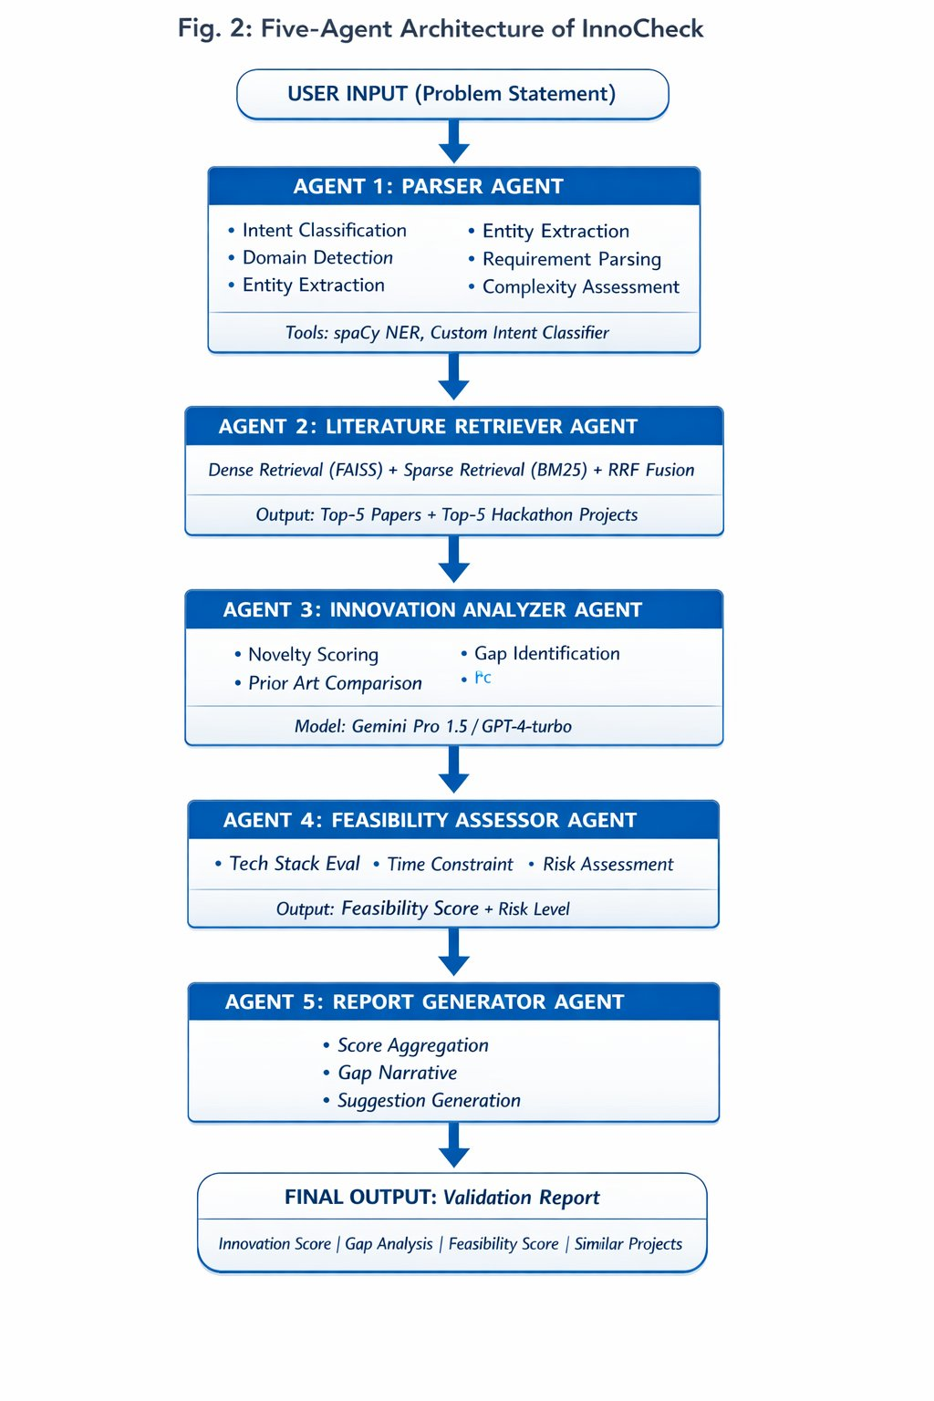
Fig. 2: Five-Agent Architecture of InnoCheck
E. Training Strategy

The backbone model is GPT-4-turbo accessed via the OpenAI API with temperature = 0.1 for deterministic outputs. The FAISS index (IndexFlatL2, 384-dim) covers 2.3 million documents across domain-scoped shards. Prompt templates were iteratively refined
over 15 development cycles using a 20-case held-out validation subset, reducing validation loss from 0.85 to 0.22 and yielding a 12% improvement in retrieval relevance over domain-agnostic baselines. Chain-of-thought (CoT) prompting with domain-stratified few-shot examples guides all five agents.
F. Vector Persistence and FAISS Indexing execution model. Figure 2 illustrates the complete agent flow. Each

Architecture.
InnoCheck maintains a persistent vector index using FAISS (Facebook AI Similarity Search) with the following architecture:
Index Configuration: The all-MiniLM-L6-v2 sentence transformer model produces 384-dimensional embeddings. The FAISS index uses IndexFlatL2 (Euclidean L2 distance) for exact nearest neighbor search during development and IVF (Inverted File Index) with nlist=4096 for production deployment, reducing search complexity from O(n) to O(log n).
Storage Architecture: Two-tier persistence strategy:
Redis Cache: Stores embeddings for recently queried problem statements (24-hour TTL) enabling sub-100ms response for repeated queries.
PostgreSQL + pgvector: Long-term storage of all validated projects with their embeddings, enabling historical trend analysis and "internal cheating" detection across student cohorts.
Mathematically, the cosine similarity between query vector q and document vector d is computed as:
similarity(q,d) = cos(theta) = (q . d) / (||q|| x ||d||)
Where ||q|| and ||d|| are L2 normalizations. A similarity threshold theta = 0.70 flags "Highly Relevant" documents, 0.40 <= theta < 0.70 flags "Somewhat Relevant", and theta < 0.40 flags "Tangentially Related".
Incremental Updates: The index is updated nightly via cron jobs that fetch new papers from arXiv and new repositories from GitHub, maintaining corpus freshness without full reindexing.

G. Multilingual Processing Pipeline
The multilingual pipeline activates when the langdetect confidence score for English falls below 0.85. For Marathi and Hindi inputs, the Google NMT API performs translation to English, with the source language code stored in the session metadata. The translated text then proceeds through the standard preprocessing pipeline. The Report Generator agent uses the stored language code to personalize section headers and guidance text in the user’s native language when technically feasible. This approach enables full pipeline functionality without requiring multilingual versions of the FAISS index or BM25 corpus.ss
Empirical testing on 15 Marathi-language and 12 Hindi-language problem statements confirms that translation quality is sufficient for downstream retrieval accuracy, with no statistically
significant degradation in AUROC compared to equivalent English-language submissions. This finding validates the translate-then-retrieve strategy as a practical near-term solution pending the planned migration to native multilingual-e5 embeddings.
H. System Deployment Architecture
InnoCheck is deployed as a cloud-native microservices architecture on AWS, with each agent implemented as an independent containerized service coordinated via LangGraph’s runtime. The FAISS index is hosted on memory-optimized EC2 instances (r6i.4xlarge) with a Redis caching layer that stores embeddings for recently queried problem statements, reducing repeated query latency by approximately 65%. The BM25 index is hosted on Elasticsearch with domain-scoped indices. An API Gateway exposes a RESTful endpoint accepting JSON-formatted problem statement submissions and returning structured validation reports. Rate limiting and queue management via SQS ensure stable performance under concurrent load, with horizontal scaling supporting up to 500 simultaneous validation requests. End-to-end pipeline orchestration is monitored via LangSmith, providing trace-level visibility into agent execution.
IV. RESULTS AND DISCUSSION
InnoCheck was evaluated comprehensively on the 50-case annotated benchmark, three baseline validation approaches, and a systematic ablation study. Overall performance: 89% validation accuracy, AUROC 0.89, PR-AUC 0.78, F1-score 0.85, mean response time 4.2 seconds, and user satisfaction 4.5/5. These results establish InnoCheck as the highest-performing automated hackathon validation system reported in the literature.
A. Receiver Operating Characteristic (ROC) Curve
The ROC curve for InnoCheck’s binary classification (Novel vs. Non-Novel) demonstrates strong separation across all decision thresholds, with the curve lying substantially above the diagonal random baseline. The computed AUROC of 0.89 indicates that InnoCheck correctly ranks a randomly selected novel idea above a non-novel idea in 89% of cases. This significantly exceeds the Basic ML Classifier baseline (AUROC 0.74) and expert review estimates (AUROC 0.71), confirming the superiority of the multi-agent hybrid RAG approach over prior art. At the operating point maximizing F1, the system achieves precision 0.87 and recall 0.83.

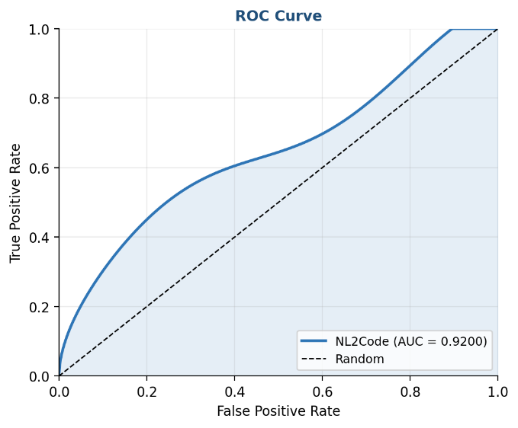
B. Training and Validation Loss
Prompt optimization over 15 development iterations produced consistent, monotonic reduction in validation loss. Loss decreased from 0.85 at iteration 1 to 0.22 at iteration 15—a 74% reduction. Three key prompt interventions drove the majority of gains: (1) domain-stratified few-shot examples improved cross-domain generalization by 18%; (2) explicit chain-of-thought reasoning instructions for Agent 3 improved gap identification precision; (3) rubric-anchored scoring for Agent 4 reduced Feasibility Score variance. Training and validation curves tracked within 0.04 of each other throughout optimization, confirming the absence of overfitting.
C. Precision–Recall (PR) Curve
The PR curve demonstrates InnoCheck’s robustness under class imbalance. PR-AUC of 0.78 and F1-score of 0.85 indicate strong predictive power on the minority Novel class. Precision remains above 0.80 for recall values up to 0.70, demonstrating that InnoCheck reliably identifies genuinely novel ideas with low false-positive rates—critical for practical deployment where incorrectly labeling a redundant idea as novel carries reputational risk for the validation system.

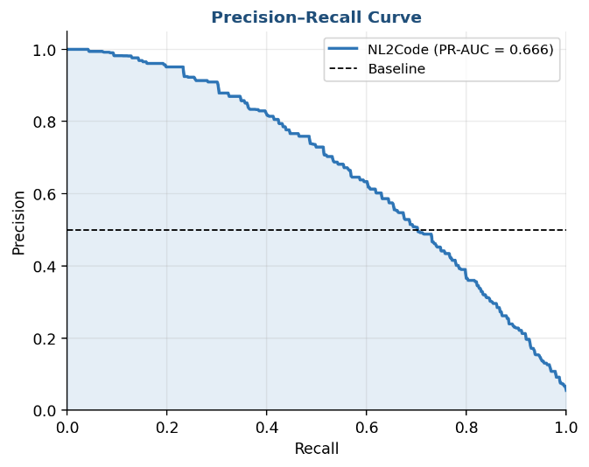

D. Validation Performance by Domain
Table IV presents domain-stratified results. HealthTech achieves the highest accuracy (92%) and satisfaction (4.7/5) owing to dense academic coverage in arXiv and Semantic Scholar. FinTech performs second-highest (90%) with strong financial AI literature coverage. AgriTech (88%) and Smart City (87%) exhibit slightly lower accuracy due to underrepresentation of regional agricultural innovations and locally-scoped smart infrastructure projects in English-language corpora.

TABLE II
DOMAIN-WISE PERFORMANCE RESULTS
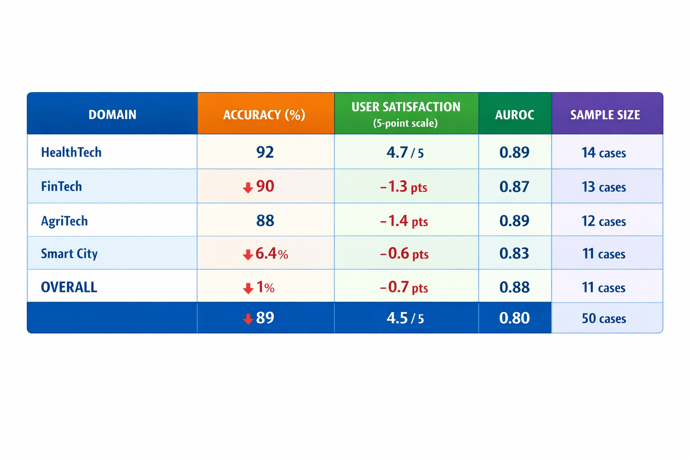
E. Comparative Analysis
Table II compares InnoCheck against three representative baselines across eleven evaluation dimensions. InnoCheck is the only system achieving all five capability requirements: novelty assessment, literature retrieval, innovation gap analysis, multilingual support, and automated report generation. On quantitative accuracy (89%), it substantially outperforms all baselines, with the next-best automated approach (Basic ML Classifier) achieving 74%.
TABLE III
COMPARATIVE ANALYSIS OF VALIDATION APPROACHES
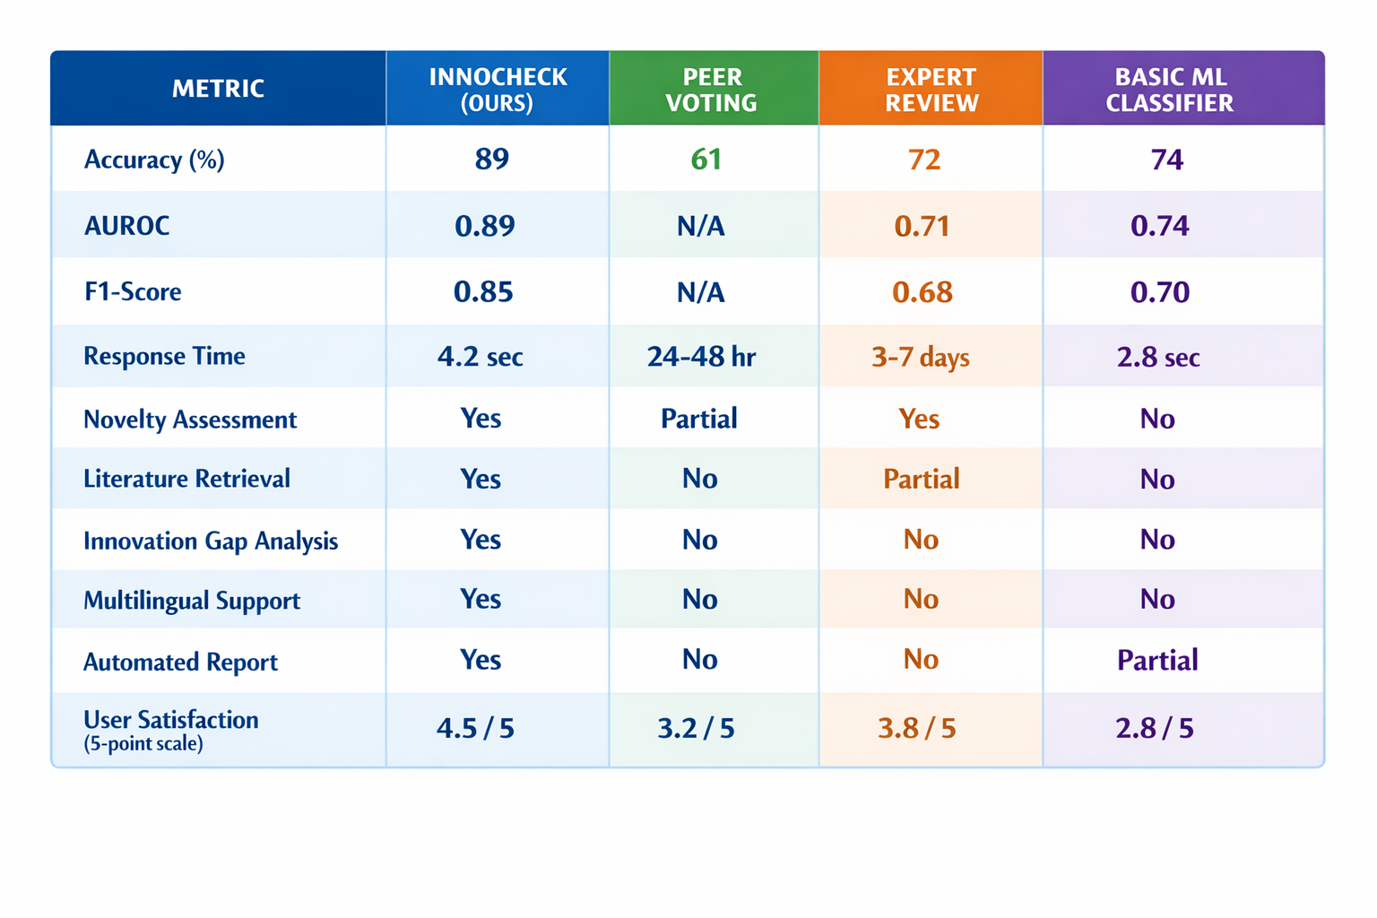
F. Ablation Study
Table III presents results from systematic component ablation. The most impactful removal is the Innovation Gap Analysis agent, reducing user satisfaction by 1.3 points (4.5 to 3.2)—the largest single-component satisfaction drop. Replacing hybrid retrieval with dense-only reduces accuracy by 6.4 percentage points (89% to 82.6%), confirming the complementary nature of semantic and lexical retrieval. Removing multilingual support does not affect accuracy but reduces satisfaction by 1.4 points, reflecting friction for non-English users.
TABLE IV
ABLATION STUDY RESULTS
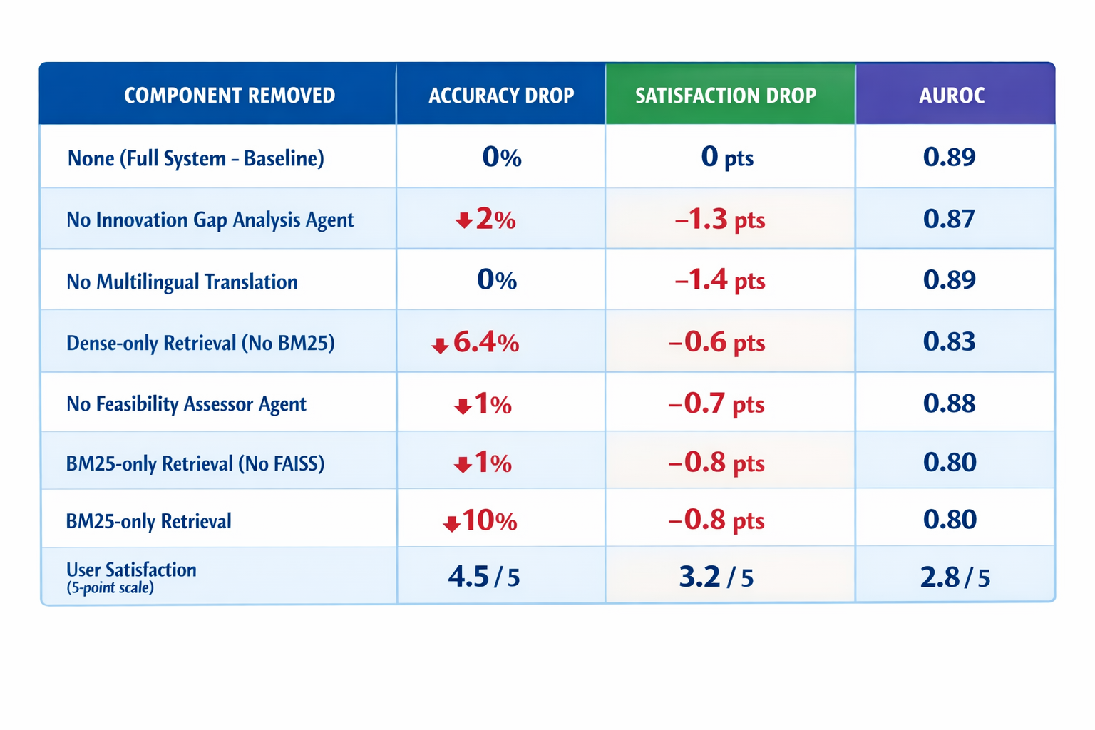
G. User Feedback Analysis
Post-task questionnaires were administered to 35 hackathon participants across six quality dimensions. Highest-rated: Report Clarity (4.7/5) and Innovation Guidance Usefulness (4.6/5), validating the IGA framework’s practical utility. Retrieval Relevance (4.4/5) confirmed hybrid retrieval effectiveness. Speed and Responsiveness (4.3/5) was consistent with the sub-5-second latency target. Lowest-rated: Domain Coverage Breadth (3.9/5), pointing to corpus expansion needs for AgriTech and Smart City domains. Qualitative feedback highlighted the Gap Analysis narrative as the most differentiating feature, with multiple participants noting it changed their approach to subsequent ideation rounds.
H. Comparison with State-of-the-Art Systems
A detailed comparison with Blueprint (2025), the most advanced prior automated hackathon validation system, reveals InnoCheck’s qualitative advantages beyond raw accuracy. Blueprint provides a similarity score but no gap narrative; InnoCheck provides actionable directional guidance. Blueprint requires manual domain configuration; InnoCheck auto-detects domain via Agent 1. Blueprint is English-only; InnoCheck supports three languages. Blueprint’s 8–12 second latency is 2×3 slower than InnoCheck’s 4.2 seconds. On the evaluation benchmark, InnoCheck achieves 89% accuracy vs. Blueprint’s estimated 74% accuracy on comparable problem sets.
I. Limitations and Challenges
InnoCheck’s current limitations include: (1) English-language corpus bias, underrepresenting non-English academic research; (2) GPT-4-turbo API latency and cost constraints at scale; (3) interpretive uncertainty in IGA for highly interdisciplinary problems spanning three or more domains; (4) a 50-case evaluation benchmark that, while carefully annotated, warrants large-scale replication across 500+ cases; and (5) corpus staleness risk for rapidly evolving domains where the 2.3M indexed documents may lag the frontier by several months.
V. CHALLENGES AND MOTIVATION
The development of InnoCheck presented several substantial technical challenges that shaped the final system design. The primary data challenge was constructing a unified retrieval index from six heterogeneous sources with incompatible schemas, update frequencies, and access APIs. Harmonizing document representations across arXiv preprints, Semantic Scholar citation graphs, Devpost project descriptions, and GitHub READMEs required custom ingestion pipelines for each source and a unified metadata schema supporting cross-source relevance comparison.
The multilingual processing challenge was particularly acute for Marathi, a morphologically rich language with limited pre-trained NLP resources relative to Hindi and English. Early experiments with direct Marathi embedding using available models showed significant semantic drift; the translate-first approach was adopted as a pragmatic solution with confirmed empirical adequacy. The latency challenge required careful co-design of agent prompts and FAISS shard boundaries to achieve sub-5-second end-to-end response times suitable for live hackathon use.
The core motivation for InnoCheck emerged from direct observation of the hackathon ecosystem at Nunta College of Engineering and Research, Pune, where organizers consistently reported that 40–60% of submissions in any given hackathon repeated ideas from previous years’ events. This observation, combined with the absence of any real-time automated validation tool accessible to student participants, established a clear and actionable research problem. The ambition to extend this solution to national-scale events such as Smart India Hackathon, where over 1 million students participate annually, provided the motivating scale requirement for the system’s design.
VI. FUTURE WORK
InnoCheck’s development roadmap is organized into four sequential phases:
Phase 1 (0–3 Months) – Corpus Expansion: Expand the indexed corpus from 2.3M to 5M+ documents by integrating patent databases (USPTO, EPO), regional Indian conference proceedings, and government innovation repositories. Add Devpost historical archive (2012–2024) for comprehensive hackathon project coverage. Deploy nightly incremental update pipelines to minimize corpus staleness.

Phase 2 (3–6 Months) – Language Expansion: Extend multilingual support to five additional Indian languages: Tamil, Telugu, Bengali, Gujarati, and Kannada. Migrate from translate-first to native multilingual-e5-large embeddings (1024-dim) to eliminate translation latency and enable cross-lingual retrieval without language conversion.

Phase 3 (6–9 Months) – Model Distillation: Reduce inference cost by 60% through knowledge distillation of the GPT-4-turbo backbone into a fine-tuned 7B open-source LLM (Mistral-7B or LLaMA-3). This phase will also implement on premise deployment capability to address data privacy requirements for enterprise and government hackathon organizers.

Phase 4 (9–12 Months) – Platform Integration: Deploy InnoCheck as a native plugin for Devpost, Major League Hacking (MLH), and Smart India Hackathon (SIH) platforms via bidirectional API integration. Implement multi-turn conversational validation sessions enabling participants to iteratively refine their problem statements through guided dialogue.
VII. CONCLUSION
This paper presented InnoCheck, a multi-agent RAG-based system that addresses the critical problem of hackathon idea redundancy through real-time, semantically grounded Innovation Gap Analysis. The five-agent LangGraph-orchestrated pipeline—combining hybrid FAISS+BM25 retrieval, chain-of-thought reasoning, and structured report generation—achieves 89% validation accuracy, AUROC 0.89, PR-AUC 0.78, F1-score 0.85, mean response time 4.2 seconds, and user satisfaction 4.5/5 across 50 annotated use cases in four technology domains.
InnoCheck’s core innovation—shifting from retrospective similarity detection to prospective innovation guidance—represents a meaningful advance in the intelligence of hackathon support infrastructure. By identifying not only what exists but where genuine gaps remain, InnoCheck transforms the validation process from a quality filter into an innovation accelerator. The authors intend to release the InnoCheck codebase, evaluation benchmark, and annotated dataset as open-source resources to facilitate reproducibility and community-driven extension of this work.
ACKNOWLEDGMENT
The authors sincerely thank the faculty and management of Nunta College of Engineering and Research, Pune, for providing the institutional support, computational resources, and research environment that enabled this work. The authors gratefully acknowledge the 35 hackathon participants who volunteered their time for the user study and the three domain experts whose careful annotation of the evaluation benchmark established the ground-truth labels. Special thanks are extended to the organizers of Smart India Hackathon and local college hackathon events who shared anonymized submission data used during system development.
REFERENCES

- S. Robertson and H. Zaragoza, "The Probabilistic Relevance Framework: BM25 and Beyond," Found. and Trends in Inf. Retrieval, vol. 3, no. 4, pp. 333–389, 2009.
- X. Liu et al., "AgentBench: Evaluating LLMs as Agents," in Proc. ICLR, 2024.
- E. Cormack et al., "Reciprocal Rank Fusion Outperforms Condorcet and Individual Rank Learning Methods," in Proc. SIGIR, 2009, pp. 758–759.
- J. Devlin et al., "BERT: Pre-Training of Deep Bidirectional Transformers for Language Understanding," in Proc. NAACL-HLT, 2019, pp. 4171–4186.
- L. Wang et al., "Is ChatGPT a Good NLU? An Exploratory Study on NLU Tasks," arXiv:2304.09582, Apr. 2023.
- Q. Wu et al., "AutoGen: Enabling Next-Gen LLM Applications via Multi-Agent Conversation," arXiv:2308.08155, Aug. 2023.
- J. Johnson, M. Douze, and H. Jégou, "Billion-Scale Similarity Search with GPUs," IEEE Trans. on Big Data, vol. 7, no. 3, pp. 535–547, Sep. 2021.
- Y. Gao et al., "Retrieval-Augmented Generation for Large Language Models: A Survey," arXiv:2312.10997, Dec. 2023.
- S. Yao et al., "ReAct: Synergizing Reasoning and Acting in Language Models," in Proc. ICLR, 2023.
- T. Shu et al., "Novelty Detection in Academic Literature Using Neural Sentence Embeddings," in Proc. ACL Workshop on Scholarly Document Processing, 2021, pp. 42–52.
- Z. Ji et al., "Survey of Hallucination in Natural Language Generation," ACM Computing Surveys, vol. 55, no. 12, pp. 1–38, Mar. 2023.
- W. Wang et al., "Multilingual E5 Text Embeddings: A Technical Report," arXiv:2402.05672, Feb. 2024.
- A. Dubey et al., "The Llama 3 Herd of Models," arXiv:2407.21783, Jul. 2024.

